# Transfer Function Derivation

We need to derive the control to output transfer function of our topology to be able to design a controller for it. In order to derive the control to output transfer function, we can describe our circuit in terms of state-variable vector x which consists of the capacitor voltage and inductor current. Moreover, in this derivation we analyzed the circuit for switch is opened and closed separately and averaged them. Lastly, capital letters are used for DC values and small letters are used for AC values where every component can be written as a sum of its DC and AC components. We can write the state space equations during d.Ts as follows:

(1)

Where is the input and is the output. We can write the state space equations during (1-d).Ts as follows:

(2)

Averaging the equations (1) and (2) results in:

(3)

In the first part of this equation, the coefficient of x can be called A, the coefficient of can be called B and in the second part the coefficient of x can be called C. Moreover, in this equation every term can be separated to its DC and AC components (etc. x=X+x). The only component that is not separated is the input voltage which is assumed to have no AC component. When every term is separated and the products of two AC components are neglected, we obtain the following equations:

(4)

(5)

At steady state conditions, AC terms can be neglected and results in a transfer function as follows:

(6)

Using Laplace transformation on the AC part of the equation (4) :

(7)

Expressing x(s) in terms of d(s) and combining it with the Laplace of the ac part of the equation (5) results in a control to output transfer function as follows:

(8)

In the figure below forward converter with the state variables is shown. For the switch on case (left hand side of the figure) KVL equations can be written as follows:

(9)

(10)

For the switch off case the only difference is the Vd term in the equation (9) will be zero the rest are the same with the switch on case. From all of these equations and assuming that R is much bigger than gives us the following matrices:

(11)

(12)

(13)

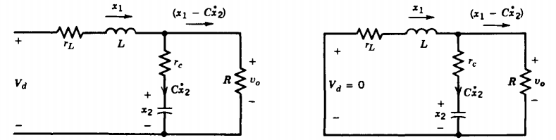

Figure : Forward converter secondary side with state variables.

All of the matrices found in (11), (12), (13) can be implemented into equation (8). This implementation results in the control to output transfer function:

(14)

In order to make this transfer function fit in the standard form, following substitutions can be made:

(15)

(16)

(17)

The transfer function with these implementations can be written as follows:

(18)

# Compensator Design

For the compensator design, we first need to find the pole/zero frequencies of the transfer function that we obtained and select a zero-crossover frequency. Zero- crossover frequency is selected as 1/5 to 1/10 of the frequency of switching. We selected it as 1/8 of out switching frequency which is 5kHz. Pole and zero frequencies are found from the equations below:

(19)

The table below shows the important frequencies of this system:

Table : Important frequencies of the system.

|  |  |  |  |
| --- | --- | --- | --- |
| F pole | F zero-crossover | F zero ESR | F switch |
| 1.239 kHz | 5 kHz | 18.651 kHz | 40 kHz |

After finding these frequencies, the next step is selecting the compensator type. This selection made with a convention taken from the book the Dynamics and Control of Switched Electronic Systems. The convention is indicated in the figure below:

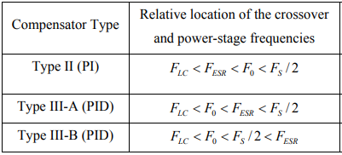

Figure : Convention for compensator type selection.

Using this convention with the frequencies that we found and indicated in the table above, gives us the result that Type III-A is the most suitable compensator type for our system.

In the Type III-A compensator approach poles and zeros of the compensator is selected as indicated below:

(20)

The formulas of this poles and zero values can be seen below:

(21)

(22)

In order to find the circuit component values, it is needed to start with attaining a value to a capacitor. In our case we selected equal to 2.2nF. Moreover, the voltage level of the sawtooth wave and the reference voltage have to be selected beforehand and which are selected as 1.8 Volts and 0.9 Volts respectively which are standard selections. Then, when the formulas given in equations (21) and (22) are used to find the required frequencies given in equation (20), the resulting circuit component values can be found as follows:

|  |  |  |  |  |  |  |
| --- | --- | --- | --- | --- | --- | --- |
|  |  |  |  |  |  |  |
| 19.5nF | 1nF | 2.2nF | 54.5kΩ | 5.4kΩ | 3.88kΩ | 8.8kΩ |

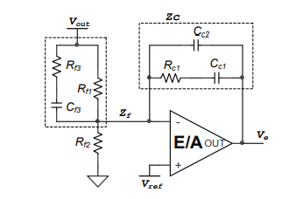

Figure : Type III compensator circuit schematic.

# Bode Plots

At first, we derived the transfer function of the forward converter. At the Figure 4 below the bode plot of this transfer function is indicated. Later, we designed a compensator in order to get a better response from our circuit. Figure 5 indicates the bode plot of the forward converter and compensator system. When we look at the bode plots, there are several differences that draws attention. Firstly, the gain of the compensated system is higher for small frequencies and stalls at high gains for a longer time. Moreover, for the higher frequencies the gain drops much faster in the compensated system. From the gain plots, one can observe that compensated system has higher DC gain and better filtering characteristics for harmonics. The desired characteristics for phase plots are having 180 degrees as the frequency increases (to filter out harmonics) and have a high phase margin (higher than 40 degrees). The uncompensated system has a good phase margin. However, as the frequency increases the phase angle stays at 90 degrees which is not desired. Type III compensator make the phase angle start from -90 degrees but thanks to the huge phase boost it still have 60 degrees phase margin and has phase angle 180 degrees for higher frequencies. To sum up all, the compensated system shows a desired behavior and its feasible for our system.



Figure : Bode plot of the forward converter topology.



Figure : Bode plot of the forward converter with the compensator.

# Transient Response

After designing our compensator and checking its transfer function with the forward converter topology, we decided to check validity of our compensator by observing its transient response. In order to observe transient response, we created the circuit schematic in LTSpice as indicated in the Figure 6 below. We observed two transient responses which are load regulation and line regulation.

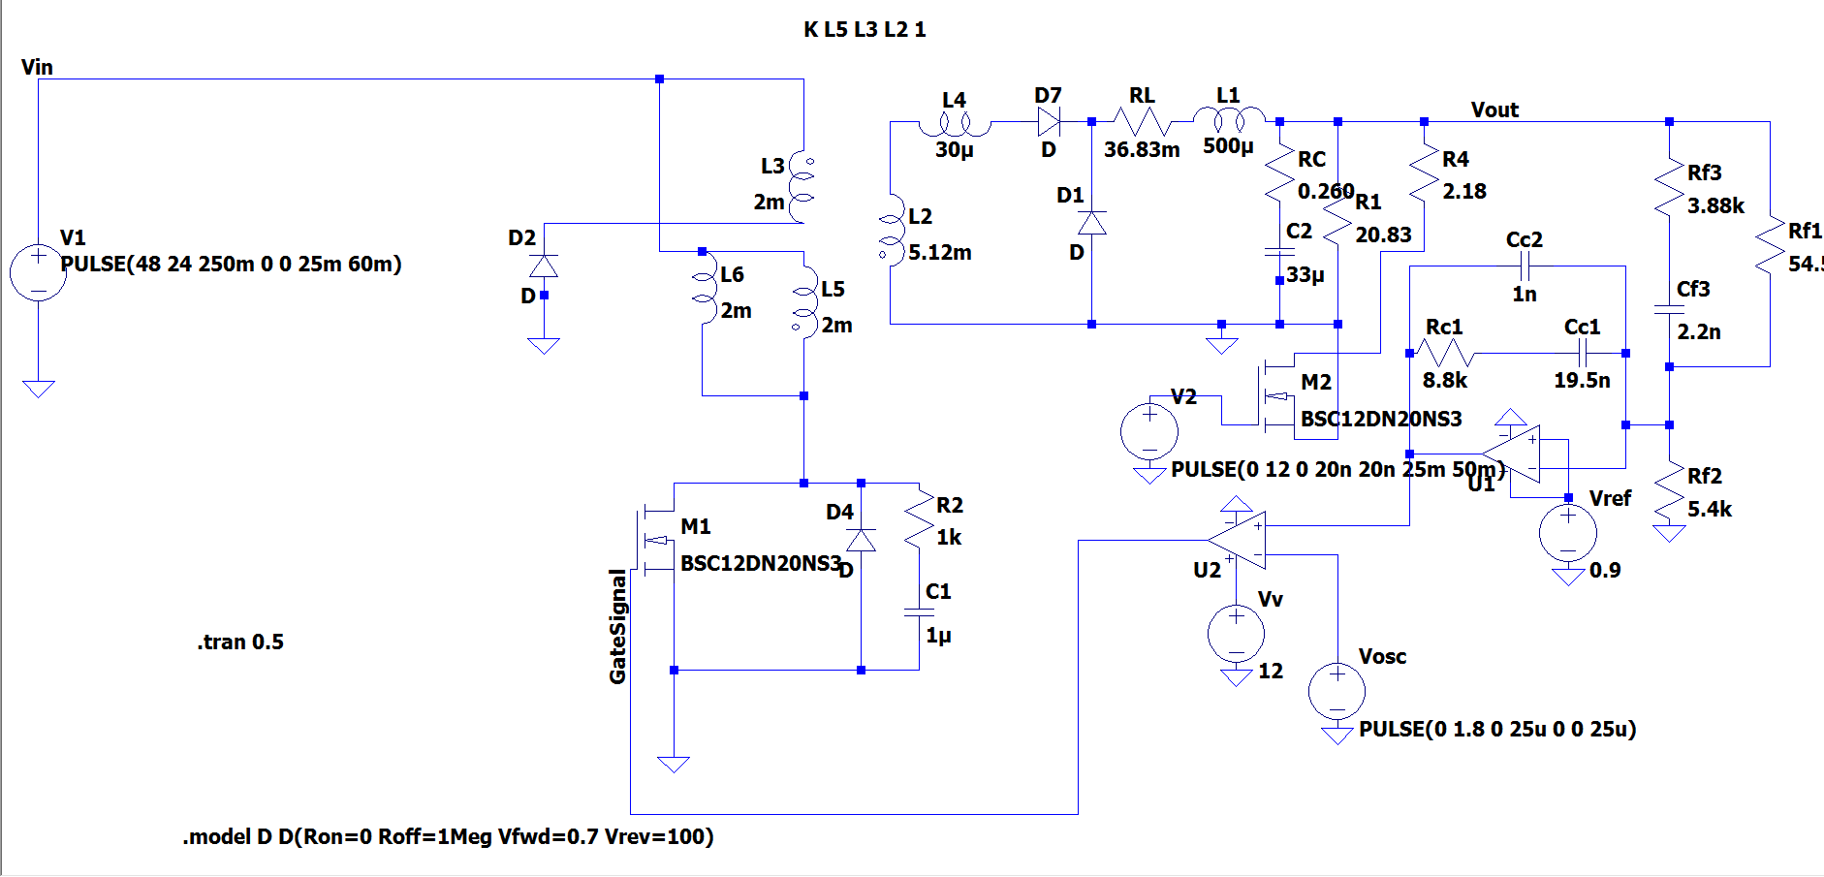

Figure : LTSpice schematic of compensated forward converter.

## Load Regulation

Load regulation is the deviation of the output voltage in percentage when the load resistance is changed from 10 times of its value to its original value or vice versa. At first load resistance is 2.083Ω and at t=25ms it is changed to 20.83Ω then at t=50ms it is returned back to 2.083Ω which is the original value. The output voltage behavior under these conditions is indicated in the Figure 7 below. At t=25ms the output voltage increases suddenly with the increasing output resistance, but it returns back to 10 volts in around 1ms. At t=50ms the output voltage decreases less than the increase at t=25ms and returns back to 10 volts in around 0.4ms.

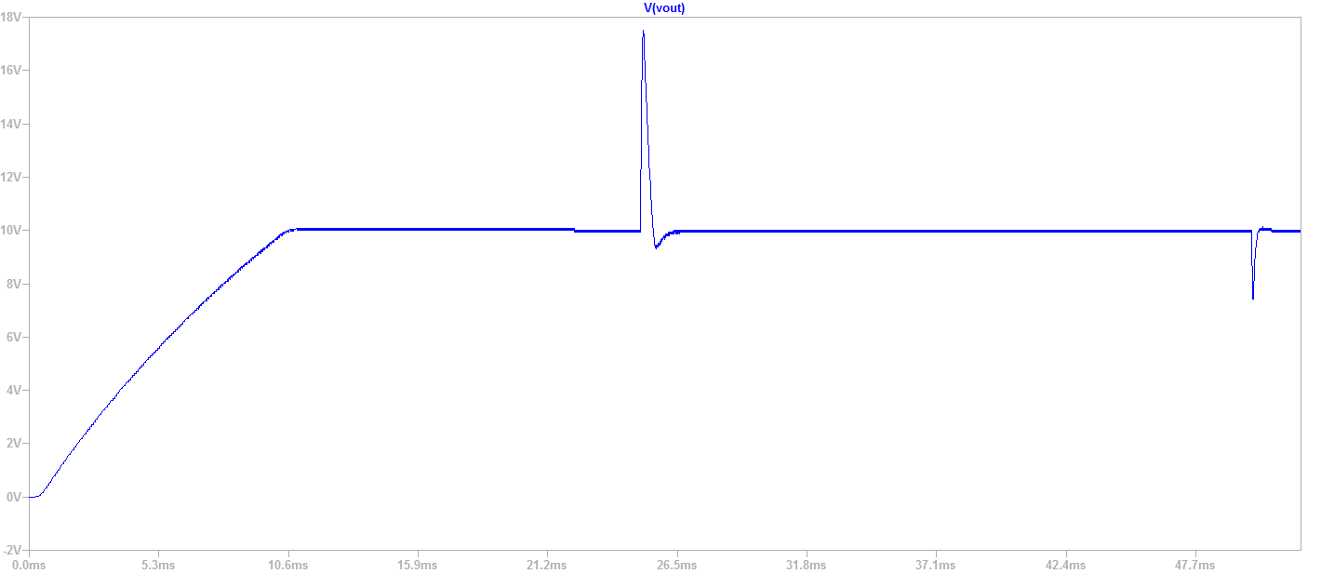

Figure : Output voltage characteristics when load is changed.

## Line Regulation

Line regulation is the deviation of the output voltage in percentage when the input voltage is changed from its maximum value to its minimum value or vice versa. At first the input voltage is 48 Volts and at t=25ms it is changed to 24 Volts and at t=35ms it is returned back to 48 Volts to be able to observe the transient changes with respect to input voltage change. When the input voltage is dropped to 24 volts and the output voltage drops a little bit and in 1.5ms it returns back to 10 volts again as indicated in the Figure 8 below. At the same time the increase in the PWM duty cycle can be seen in the Figure 9. At t=35ms the input voltage is increased to 48 Volts and the output voltage increases a little then it returns back to 10 volts in 1.5ms.

We looked at our system’s transient response and from all of our observations we can clearly say that the compensator design is feasible for this project.

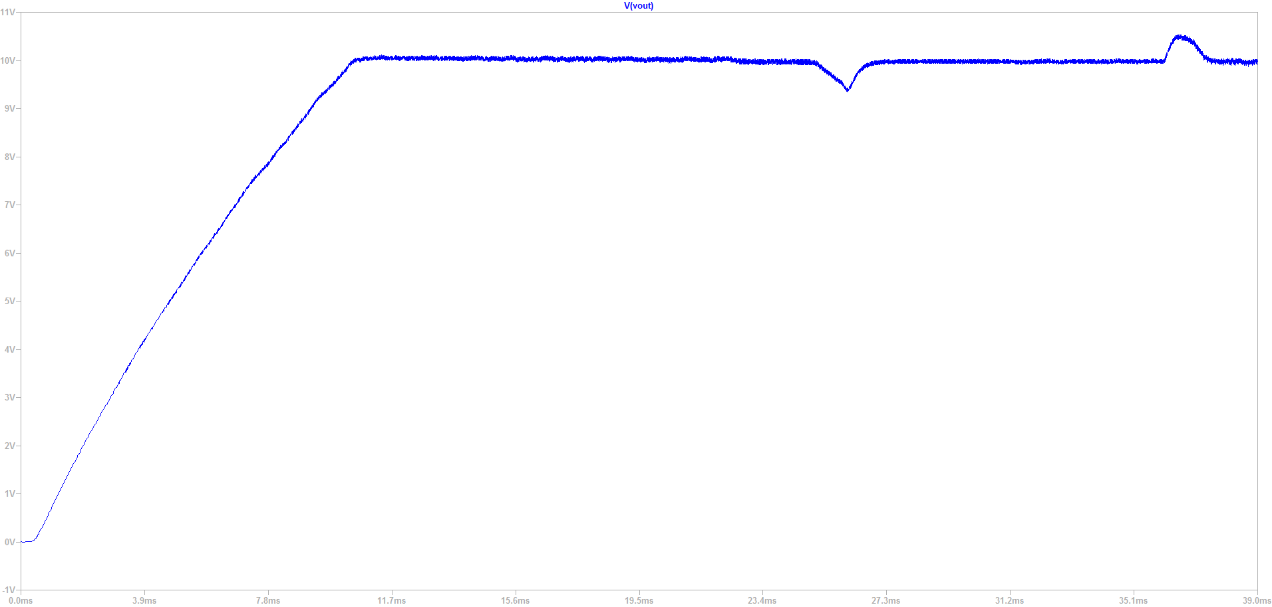

Figure : Output voltage characteristics when the input voltage is changed.

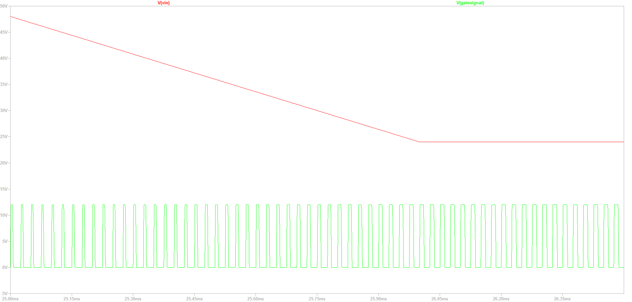

Figure : PWM characteristics when the input voltage is changed.